1 Gallon = | 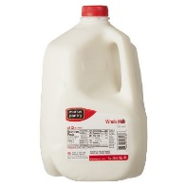
1 Teaspoon =  Tsp | 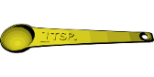
Pesticide
KEY

BT- Dipel (dry)
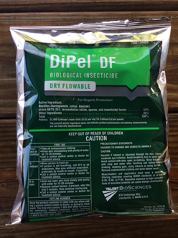

**Note: Sq. foot conversion to number of beds in the table below is approximate. The range of how much DiPel to apply per sq. foot is wide and therefore extreme accuracy in space application isn’t crucial.**

Bed Size  150 sq ft  or  one 50 foot bed | Bed Size  300 sq feet or  one 100 foot bed | Bed Size  650 sq feet or  two 100 foot beds | Bed Size  1,000 sq feet or  three 100 foot beds | Bed Size  1,300sq ft  or  four 100 foot beds
How Much?  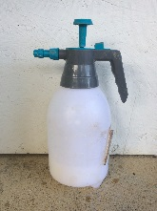  ½ gallon | How Much?  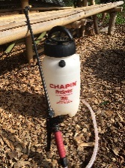  1 gallon | How Much?  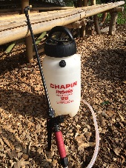  2 gallons | How Much?  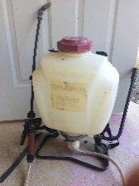  3 gallons | How Much?  4 gallons
Directions | Directions | Directions | Directions | Directions
1 Teaspoon of Dipel | 2 Teaspoon of Dipel | 4 Teaspoon of Dipel | 6 Teaspoon of Dipel | 8  Teaspoon  of Dipel
Add  Water  ½ gallon | Add  Water  1 gallon | Add  Water  2 gallons | Add  Water  3 gallons | Add  Water  4 gallons
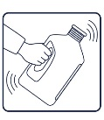  Mix | Mix | Mix | Mix | Mix

Directions
Wear mask and gloves while mixing
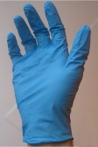
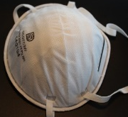

Spray tops and bottoms of leaves. Spray every 4 days
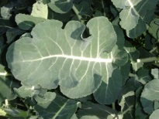

Only spray at Dawn or Dusk!

DO NOT spray when very sunny or hot.

DO NOT harvest for 24 hours
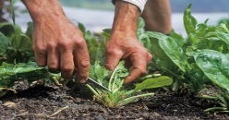

What and How
1) Larvae ingest DiPel’s crystal proteins from treated leaves.
2) Feeding stops within minutes after crystals are solubilized in the gut and gut cells are damaged.
3) After toxin damage to gut, spores enter through gut wall and germinate rapidly in body cavity causing blood poisoning.
4) Larvae stop feeding in as little as half an hour and die in 1-3 days.

Pests
larvae of lepidopetras, Specific to leaf-eating caterpillars, gypsy moth, tent caterpillar, cabbage looper, tomato hornworm, leafroller
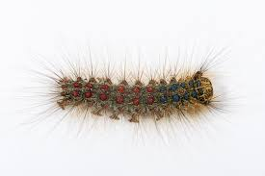
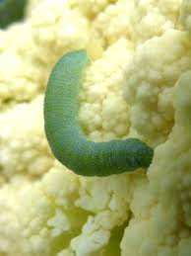
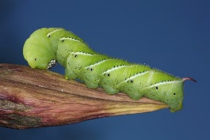
Where to Buy
Country Farm and Home
101 S Small Street, Pittsboro, NC 27312

Fifth Season
106 S Greensboro St Ste D, Carrboro, NC 27510

Internet

Cost
16 oz = $24.00

