(Johnnyseeds.com) | FLAME WEEDER
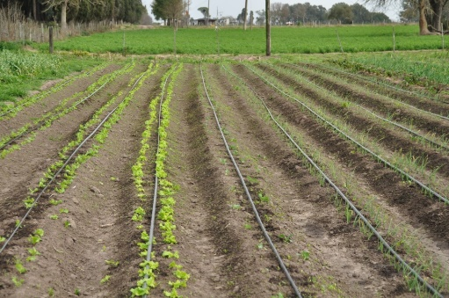 | DRIP TAPE
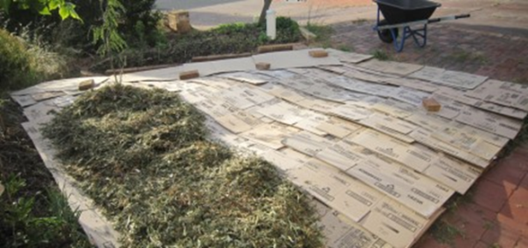  (Photo: shaunsbackyard.com) | SHEET MULCH
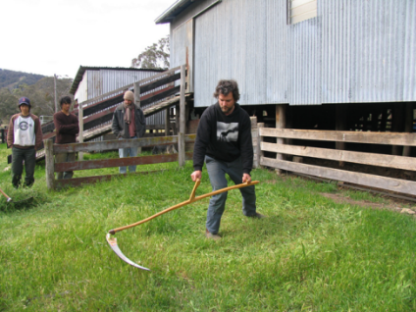 | SCYTHE
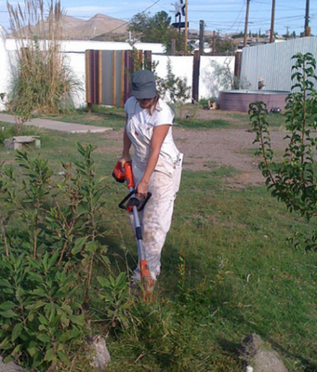 | WEED WACKER
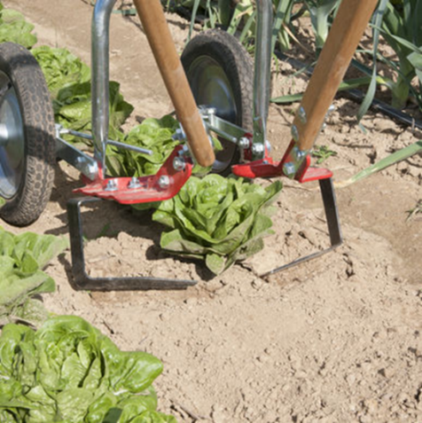  (Photos: johnnyseed.com) | WHEEL HOE
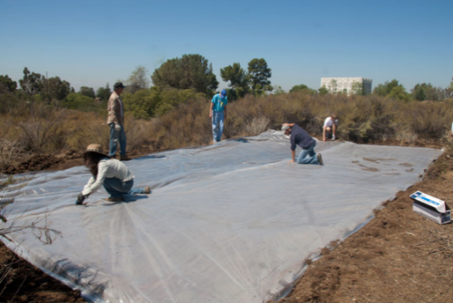  (Photo: research.pomona.edu) | WHITE PLASTIC
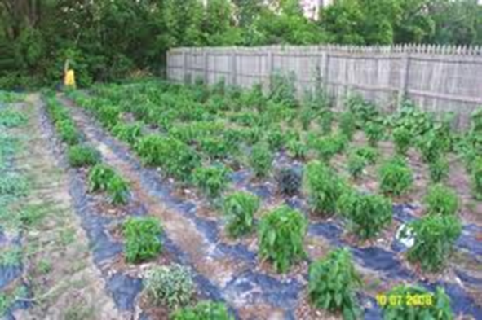 | BLACK PLASTIC

